Submit Study Abroad Program Update/Renewal and Budget Electronically

- Click the link supplied on the email
- Select the Available Term (2018 Term will be listed)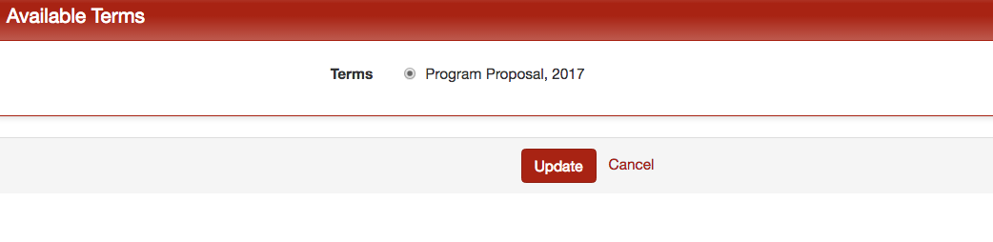
- Under the Forms to Complete section, select Faculty Led Program Proposal – Renewal
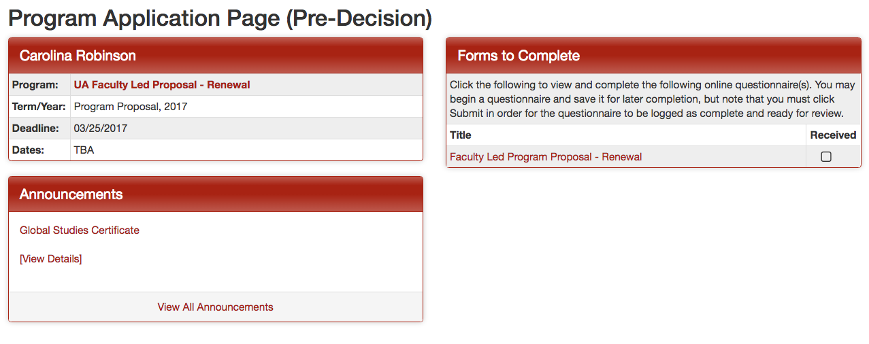
- Upload a signed copy of the Renewal Form and an electronic (.xls or .xlsx) version of the budget. Not a PDF version of the budget. 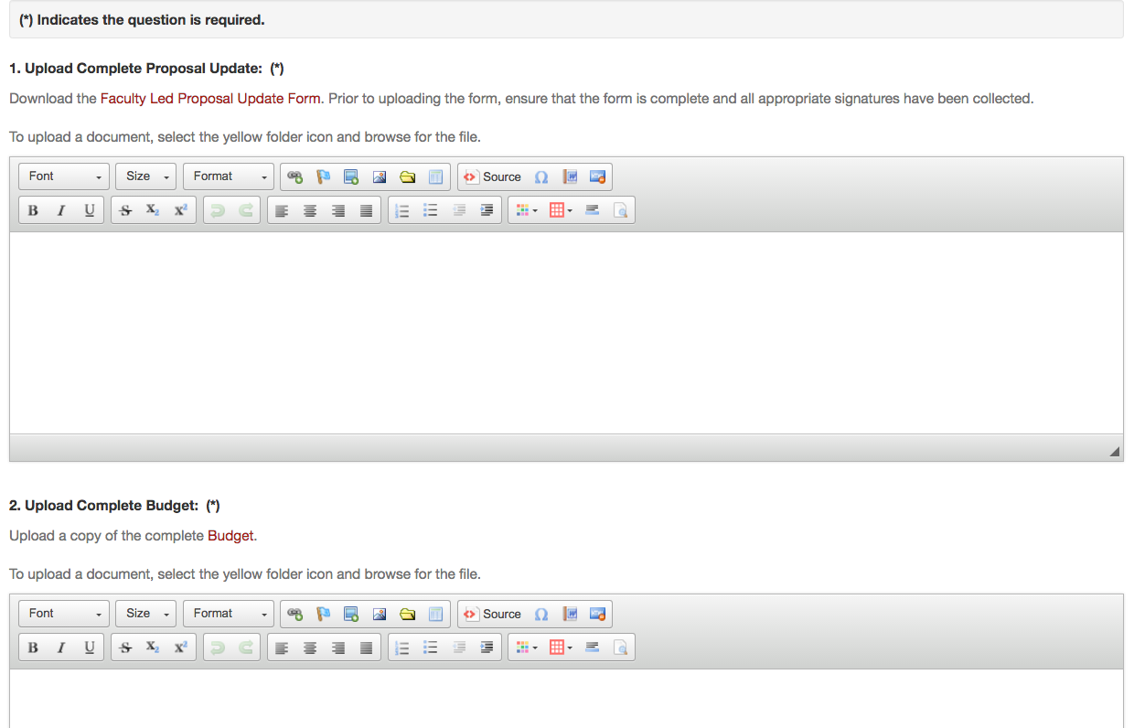
Click yellow folder
Click yellow folder

